LeCoon

User manual
multifunctional toy related to IOT devices (Internet of things)

IMPORTANT! WORKS WITH WIFI! Use only 2.4GHz. Disable automatic connection to 5GHz during setup.
BE SURE TO CHARGE THE BATTERY FOR 4-5 HOURS BEFORE USE
Registration
- Download "LeCoon" app from APP STORE (Racoon 2021) or "LeCoon" (Racoon2020) from GOOGLE MARKET. You can use the link to the application on the main page at the bottom of the enotdrug.rf website.
- After launching the application, go through the registration according to one of the proposed options. For iOS phones, we recommend signing in with your Apple ID.
- After registration, enter the required data for user registration and proceed to setting up the toy. We do not do mailings, but this is necessary for notification in case of various situations.

Toy customization
- It is advisable to place the toy directly on the router, and is located not far from LeCoon. For users of branded routers of providers- these routers often have a weak WIFI signal transmitter, so the operation of the LeCoon can be very unstable. See the section below on WIFI. The network must work at 2.4GHz and the phone must be connected to it. At 5GHz, the toy will not be able to connect to the application. Disable automatic connection to the 5 GHz network.
- Turn on the toy by sliding the lever on the side of the toy towards the red LED. When the toy turns on, the yellow LED will light up.
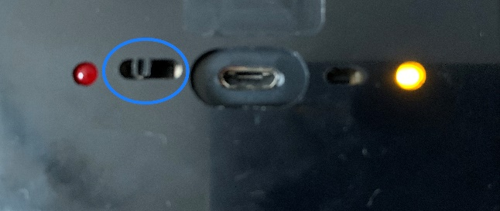
- If the LED does not light up, then the battery is most likely dead and needs to be recharged. Read the "Charging your device" section
- After turning on the toy, press the button with a thin rod to reset the settings and hold for 1-2 seconds.

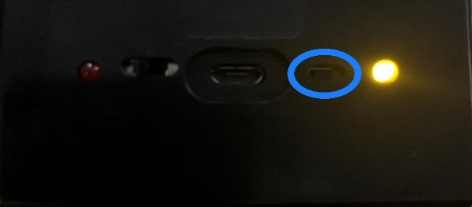
- In the app, select Settings-Devices-Set up a new device.

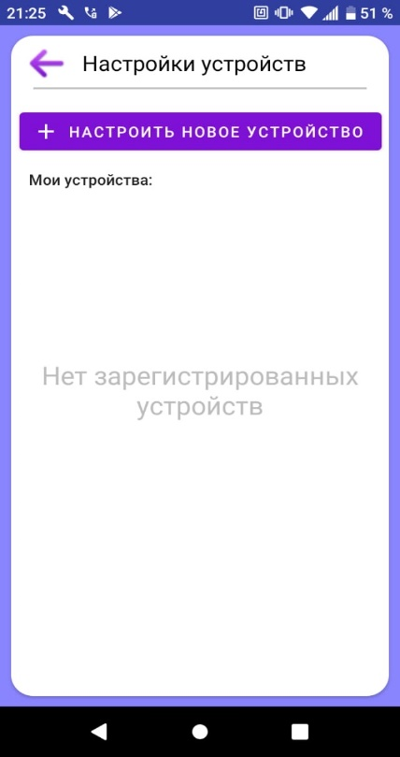
- The app will prompt you to connect to the Racoon_apsta network. This network is created by the toy itself and you need to connect to it for configuration.
- After that, the application will prompt you to select the Wi-Fi network to which you want to connect the toy and enter the network password to connect the toy. Observe the case, make sure that after entering the password, a space is not automatically added at the end.
- After that, the toy will start connecting to the Wi-Fi network. The process will be displayed on the screen.
- Sometimes the toy writes that it cannot connect to the Racoon_apsta network. In this case, you need to check the presence of the Racoon apsta network on the phone, in WIFI networks. It may not appear immediately, but after updating the networks, within 30-40 seconds. If it is not there, then you need to write to the support service on Whatsapp + 33-643-67-42-47. If there is a network, then you need to return to step 5 and continue the configuration.
- After the configuration, a message will appear that the configuration has been completed / the device has been added and the device will appear in the list of devices.
- Sometimes the device is not visible in the playlist, the application writes that the device is not visible, while the device itself is displayed in the list. In this case, close and open the update information application.
- If the toy does not connect the first time, then click "repeat". In exceptional cases, you will have to repeat this step 3-4 times.
- In rare cases, a toy for Android phones writes that the device cannot connect to the Raccoon_apsta network. After several attempts to "repeat" the message continues to appear. In this case, you need to go to the phone settings, connections and select the WIFI item. In available WIFI networks, find the Raccoon_apsta network and connect it. After connecting to it, go to the toy application and continue setting up. You can write to the support service on Whatsapp ++33-643-67-42-47 and we will send you a video on how to do it.
- If after that the toy is not configured, then write to the support service on Whatsapp +33-643-67-42-47.
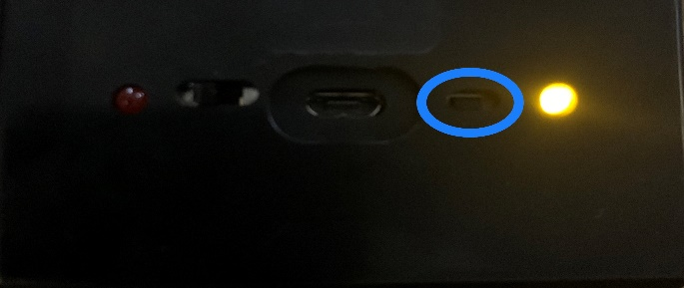
- After the toy is configured, then close and open the application or make a refresh (pull the screen down). The name of the device should appear on the Set Up a New Device screen, under My Devices.
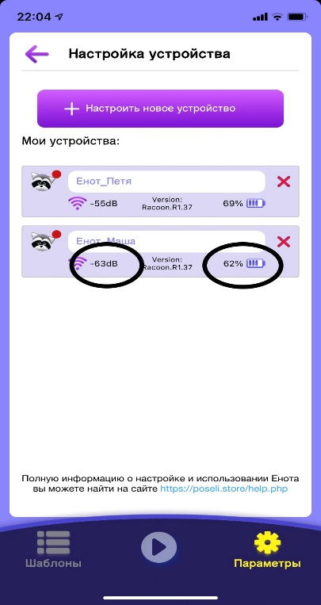
- On the left, you will see the level of the signal that LeCoon feels when he is in this place. If the signal level is lower - 85-88 db (the larger the number model, the worse the signal), then the toy may work unstable, namely, a delay in playback, possible interruptions in playback. If playback is already in progress, then if it is interrupted due to signal loss, the file will start playing from the beginning.
- On the right you can see the battery charge level. We recommend not to wait for extreme values, and put on charging at 10% and remove from charging at 90%.
- If you experience difficulties in setting up the toy, then write to the Whatsapp support service +33-643-67-42-47, where they will help you.
- After the first connection of the toy to the network, it is possible to update the toy, about which the LeCoon will report and ask you to wait. It is advisable to wait about 1 minute, as the toy will receive a firmware update and report the end.
- The toy is ready to use.

New WI FI hotspot
- If you need to connect a new access point, for example, you came to a new place with LeCoon, then for this, when a new point is available, without deleting anything, go to the settings and reconfigure the device, as you did before. Do not press the reset button or remove the toy from the app. Just wait 30 seconds before tuning. Only if the toy is not configured and writes that it cannot connect to the Raccoon apsta LeCcoon network, in this case, press the reset button on the toy. IMPORTANT. There is no need to remove a toy from the application in any case.
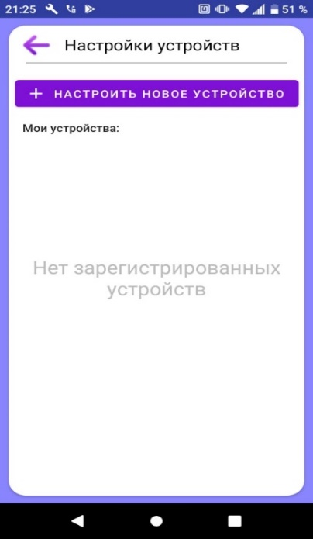
- After deleting the toy from the app, you must re-do all the steps in the "Setting up the toy" section, with the exception of resetting the settings on the device itself.
- If you constantly come to another place, then in order not to set up LeCoon every time, then name your network in this place the same as in a permanent place. And give the same password. Then LeCoon will always connect automatically.
- The LeCoon remembers the places where it has been configured and automatically connects where it has already been. But before that, for a few seconds, he will try to connect to the old access point if the network name and password are different in the new place where he was brought from. But not finding the old location, it will find a familiar network in the new location and connect to it.

Playback
Sending a text message or recording your voice
- Sending a text or voice message is very similar to communicating in popular instant messengers, so it should not be difficult to use.
- IMPORTANT.The volume of messages and files is adjusted at the top of the playback screen by clicking on the "speaker" icon.
- On the main screen, enter the text message you want to send at the bottom. The amount of text is unlimited.
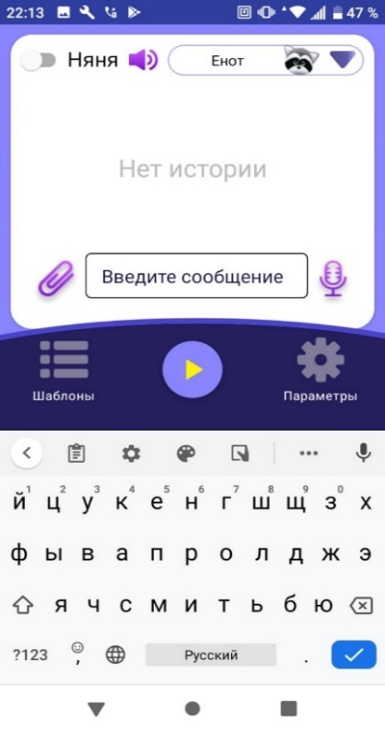
- After entering, send a message to the toy
- All new files that the device receives are displayed below those previously received.
- The toy will receive a message and to play it, you must press the "play" button, which is located to the right of the file name.
- After that, the toy will play it in the voice that you have selected in the "Speech Synthesizer" profile. There are now two synthesizers in the toy - Google and Rhvoice, when you click on the "Speech synthesizer" button, a list of synthesizers appears. Google Synthesizer has more natural speech based on artificial intelligence, and we recommend using it. In addition, this synthesizer has a large number of different voices, when you click on the "language" button, a list drops out. The Rhvoice synthesizer has rare languages ​​such as Tatar, Georgian, Kyrgyz, etc. But the speech of this synthesizer is less natural.
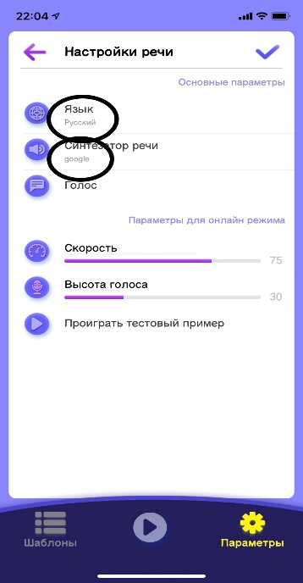
- Playback is one by one, after one file ends, another one will start playing.
- If you want to change the voice, speed or pitch of the voice, then you need to recreate the text and send it for playback. Repeating the old file with the new parameters will not change anything. The new settings will only apply to the new message.
- In the app on your phone, you will see the message being played back.
- If you want to record and send your voice for playback by the toy, then you need to press and hold the "microphone" icon in the lower right corner.
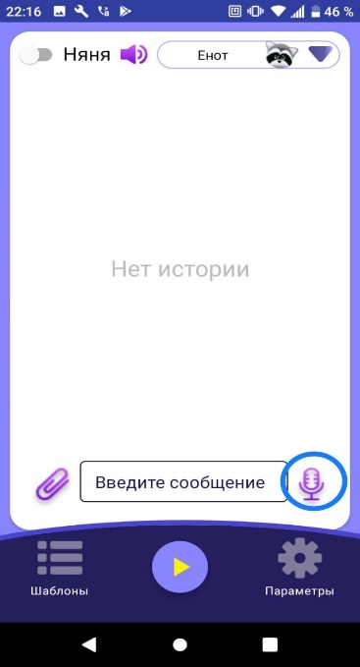
- Recording will continue as long as you keep the 'microphone' pressed. After you release the "microphone", the recording of your voice will be queued.
Playing audio and text files
- On the main screen, click on the paperclip icon in the lower left corner.
- By clicking on the paperclip, you can select a file from different sources. Templates - a file that you created yourself and saved in the "templates" folder in the application. You can also select a file to play from a folder in your phone's memory where you save your files when downloading from the Internet.
- You can select several files at once, you can select one and add to the playlist.
- You can also use the files that our users have downloaded to the library on the server, with a small number of stories, songs and fairy tales, from where you can also play.
- Click on the paperclip and select the file you want to play in the folder.
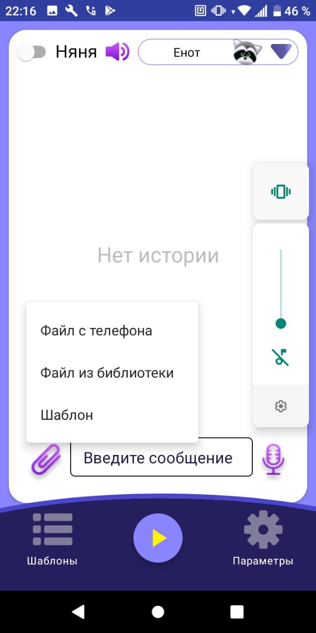
- Select the file you need and send it to the toy.
- The toy will play the sent file. If it is a text file, then the toy will voice it in the previously selected voice, if it is an audio file, it will play it after pressing the "play" button.
- Note that if you change the speech synthesizer settings, the new settings will only apply to the new text message.
- In the app on your phone, you will see the message being played back.
- When using the "playback" mode, an indication works on the top of the toy (the LED lights up), indicating that the speaker is being used.
- If you want to play a file that is downloaded later, then you need to click on the "play" icon to the right of the file you need. All higher files will be skipped and the file you need will start playing. If the file did not start playing within 5-6 seconds, but the icon turned yellow, then press the “play” icon again a couple of times.
- If you want to repeat or delete a file that has already been played, then swipe it to the left and select the item you need. In the case of "repeat" the file will appear at the bottom of the list.
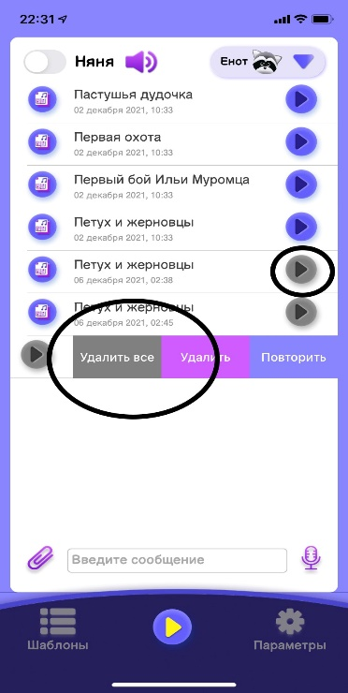
- IMPORTANT.If you submitted a file for playback and the icon to the right of the file turns yellow with two stripes, it means that the file has arrived at the server and has been sent to the toy. But if there is no playback, then there is no connection between the toy and the server due to a bad WIFI signal.

Radio communication
- The toy is equipped with a microphone, which is located inside the toy in its middle part to use the "radio communication" mode, which is activated by a switch in the upper left corner in the mobile application.
- When you turn on the “radio communication” mode, the toy will transmit sounds to your phone that will be heard in the microphone access area. At the moment, sounds are transmitted with a delay of 3-4 seconds. In this mode, you can also use the "play" mode to play files on the toy in order to calm the child, for example, put on a bedtime story.
- When using the “radio communication” mode, an indication works on the top of the toy (the LED lights up), showing that a microphone is being used.
- The application does not automatically go to sleep when using the radio.
Create a template
- You can create the templates you want to record for your child and play them back.
- To do this, go to the "Templates" folder and click on the "+" button.
- After that, a window will appear in which you can add any audio file or text in the "docx" format.
- All elements from which the template is created will play in the order in which you created it.
Text-to-speech options
- You can choose to adjust the volume at which the toy will play sounds.
- You can select the speed and pitch of the voice at which the text will be read.
- You can choose the language of the text that will be played by the toy
- You can select a voice synthesizer that will voice the text
- You can choose a male or female voice
- Note that the new settings will only apply to new messages or text files. Previously created messages or voiced files will not be able to be played with the new parameters. You need to re-install the text file or type new text.
- Some services may be chargeable
WIFI
- IMPORTANT. For stable operation of the toy, the WIFI signal level must be at least - 85dbm (when setting up the toy, the WIFI signal level is shown and in this case it should not be less than -65 dbm). Otherwise, the unstable operation of the toy is possible - the playback of the audio file is jammed, the playback stops.
- If the WIFI signal check shows a low level, then you need to install a WIFI signal amplifier. Check the possible model with your Internet operator. You can choose any suitable for your router.
- IMPORTANT. When setting up a signal amplifier in an apartment or house, it is advisable to set a different network name, not the same as that of a home network with the same password. WIFI signal amplifiers allow you to do this in the settings. In this case, LeCoon will not confuse networks and will be connected to the network that provides reliable reception. Also, you yourself will understand which network the toy is connected to.
- But if you are setting up a new access point in a different location where there is no current WIFI network, then it is more correct to leave the same name and password. Then the toy will automatically connect to a new access point without configuration.
Charging the device
- To charge the toy, you need to connect it to a microUSB charger (Not included). To do this, the device board has the same connector to which the charger itself is connected.
- Use branded chargers of large companies. The outlet itself is important, not the cord.
- Do not use chargers that are used for vapers, Iqos and the like. Use cell phone sockets with a current of 1A or less.
- Do not charge the battery at low temperatures and fast charges.
- VERY IMPORTANT!Do not use charging with a current strength of more than 1A, as well as "fast" charging. This can lead to overheating of the device and its failure. Considering that the battery has a large capacity of 5000mAn, the battery can be charged for 12-14 hours for the first charges. Subsequently, the charging time will decrease to 8-9 hours.
- Do not allow the battery to completely discharge. This can lead to battery failure and possible battery damage. It is better to charge often and for a short time.
- When the charger is connected, the red LED will light up. When fully charged, the red diode will turn off. There is no need to wait for a full charge. Enough charging for 4-5 hours.
- When the battery is fully charged, the red LED will turn off.
- If the battery is noticeably warm, it is necessary to disconnect the device from charging and change the charger with a lower current strength.
- If in this case the battery continues to heat up, then you need to contact our technical support.
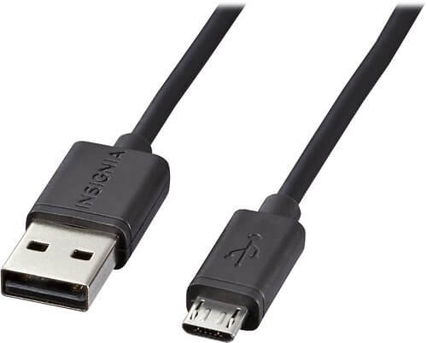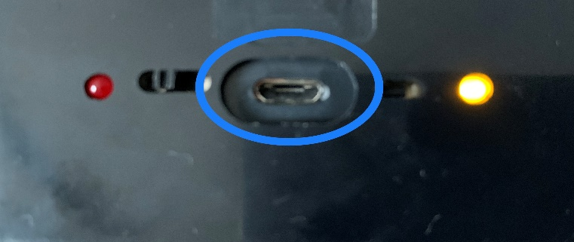

Application
- The warranty for this product is 6 months. Service life up to 24 months. In case of failure of the device during the service life, we guarantee repair at our expense. You pay only transportation costs.
- Specification
- Name: LeCoon
- Battery capacity: 5,000 mAh
- Power consumption: 37 mW in standby mode, 800 mW in player mode
- Speaker 2W, 8 ohm
- Charging time: 6 hours.
- Standby time: 48 hours
- Working time when using: 12 hours
- Details on our website https://enotdrug.rf
- Attention. The toy is equipped with a microphone and speaker. While the microphone or speaker is being used, the indicator lights up in solid green.

