ENG
LeCoon_Lite
Operations manual of a
soft interactive toy
ATTENTION! WORKS WITH BLUETOOTH
Technical support Whatsapp +33 643 67 4247
Signing up
- Download the “LeCoon_Lite” app from the APP STORE or GOOGLE MARKET. Note that there is an app called “LeCoon” that is not suitable for these toys. You can use the link to the app on the home page at the bottom at the site poseli.store.
- After launching the application, enter the necessary data in the user account profile through the “Menu” section (#1) and proceed to use the toy. We do not perform mailings, but it is necessary for notification when various situations occur and for the toy improvement.
Setting up the toy
- Turn on the speaker located in the pillow and which the toy holds. To do it, tap and hold the power button (#2) for a few seconds. The speaker will produce the sound and glow blue. If it does not, recharge the speaker.
- After that you need to go to “Settings” of the phone and open the “Bluetooth” section. There, you need to select the “LeCoon” network (#3) and connect to it. Depending on the operating system, you may need to tap the “Add Device” option. Once connected, the toy will produce the sound again indicating that it is connected to the phone.
- It is possible that the toy cannot connect to the phone. In this case, you need to remove the toy from the list of devices and tap “Add Device” again.
- The toy is ready to use. Now you can go to the application and play the files.
- Note that the operation range of the toy is about 10 meters. If you use the toy in an apartment, the operation range will be smaller in case there are walls or other obstacles between the toy and the phone.
Playback
- ATTENTION You can adjust the volume of messages and audio files at the bottom of the playback screen by moving the slider.
- You need to tap the white bar at the bottom of the screen to slide out the bottom panel for volume and file control.
- To play a file, tap the file itself or the icon to the left of the file name.
- If you want to delete the file that has already played, swipe it to the left and select the item you want.
- ATTENTION Check out the “Help” section our website to learn how to download files from the Internet to your phone
Text message or recording of your voice
- At the bottom of the main screen, tap the letter A (#4) to open the window where you can enter a text message to send. The amount of text is unlimited.
- After entering the text, tap the button to send the text, as in regular messenger.
- All new files that the toy receives are displayed below those previously received.
- The toy will play back the text message using the voice you selected in the "Menu" – "Speech Synthesizer" section (№1). The toy has two synthesizers – Google and LeCoon. When you press the "Speech Synthesizer" button, a list of available synthesizers appears. Both synthesizers provide natural speech based on artificial intelligence, but we recommend using the LeCoon synthesizer as it is better adapted for the English language and offers child-friendly.
- You can also change the voice reading the text. When you tap the “Voice” button, a list of voices will drop down, and you can choose from it the most appropriate one. The same applies to the playback speed and pitch of the voice.
- If you want to change the voice, speed or pitch of the voice, you must rewrite the text and send it for playback. Nothing changes during the repeated playback of the old file with the new parameters. The new parameters will be applied only to the new message.
- If you want to record your voice for the toy to play back, press and hold the button with the red icon (№4) in the bottom right corner. Please speak slowly and clearly to ensure your voice is recognized correctly and the toy can reproduce it using its own voice.
- The recording will continue as long as you keep the button pressed. Once you release the button, your voice recording will be added to the queue.
- If you want the toy to play back your actual voice instead of converting it into its own, you need to select "No" in the "Replace microphone voice" option in the synthesizer settings. This way, your recorded voice will be played as it is.
Schedule
      - IMPORTANT. Depending on the IOS or Android operating system, the application works with different functionality. The application should not be closed to work in "Schedule" mode.
      - To work in this mode, you need to set an alarm and create a playlist for playback. It can be text, audio file, or a recording of your voice. This can be a reminder for a child to brush their teeth, do homework, or tidy up their toys in the room.
      - At the specified time, the toy will start playing the specified files in order. If it is the IOS operating system, the application will send a notification to open the application to start the alarm.
      - If it is the Android operating system, the application has a "Parrot" feature. Here you can write any phrases that the toy will play back randomly.
Audio files
- On the main screen, there is a carousel with folders where you can upload files to the app. Enter a folder, select the desired file, and tap on it. The file will be marked as selected, and by pressing the checkmark in the top right corner, it will be added to the main screen for playback. You can select multiple files at once for addition.
- Additionally, by tapping the triangle to the right of the file, you can listen to a 5-second audio preview to understand its content.
- IMPORTANT: The folder carousel will match the language set in the app. If you want to see folders in a different language on the main screen, you need to change the language in the settings.
- To access folders in other languages without changing the app language, tap the "+" icon (№4) in the bottom right corner.
- By tapping the “+”, you can select a file from different sources — from the phone or the server. You can also create your own playlist, in which you can add different files.
- You can select multiple files at once, or you can select one file and add it to the playlist.
- Select the file you want and send it to the toy.
Charging device
- To charge the toy, you need to connect it to the charger with MicroUSB connector. A cord is included in the package with the toy (#5), a socket is not supplied. For this purpose, the speaker has the same connector (#2) to which the charger itself is connected.
- Do not use sockets that are used for vapers, Iqos and the products alike. Use cellular phone sockets with amperage no more than 1A.
- Do not leave the toy in the sun, as the battery can explode when heated by the sun rays.
- Do not charge the battery at sub-zero temperatures or using quick charge.
- When the charger is connected, the red LED will glow. In case of full charge, the red LED will turn off.
- When the battery is fully charged, the red LED will turn off.
Appendix
- This product warranty is 12 months. Service life is no less than 24 years.
- Battery capacity: 300 mAh
- Charging time: up to 2 hours.
- Standby time: more than 72 hours
- Operation time: more than 8 hours, at medium volume
- The details are provided at https://poseli.store

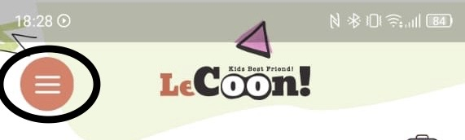  №1 | 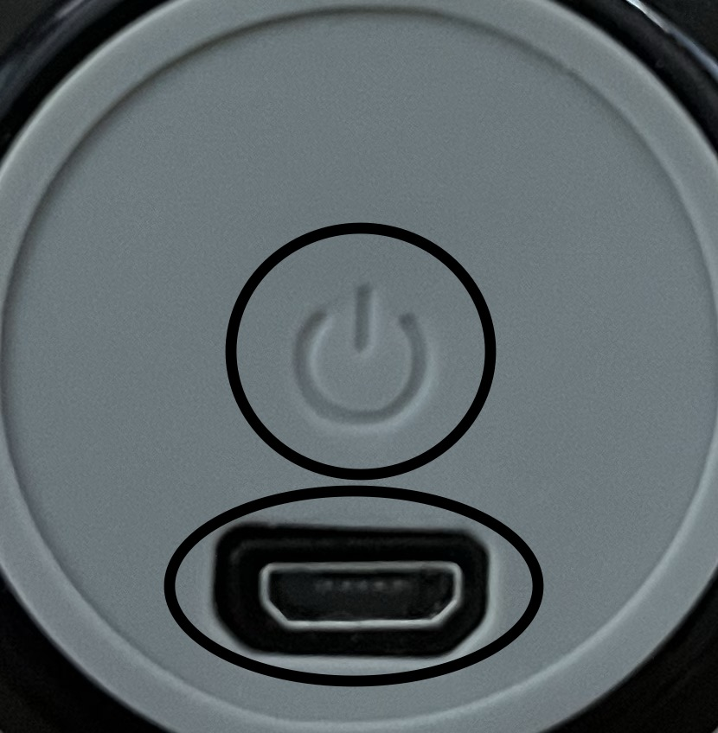  №2 | 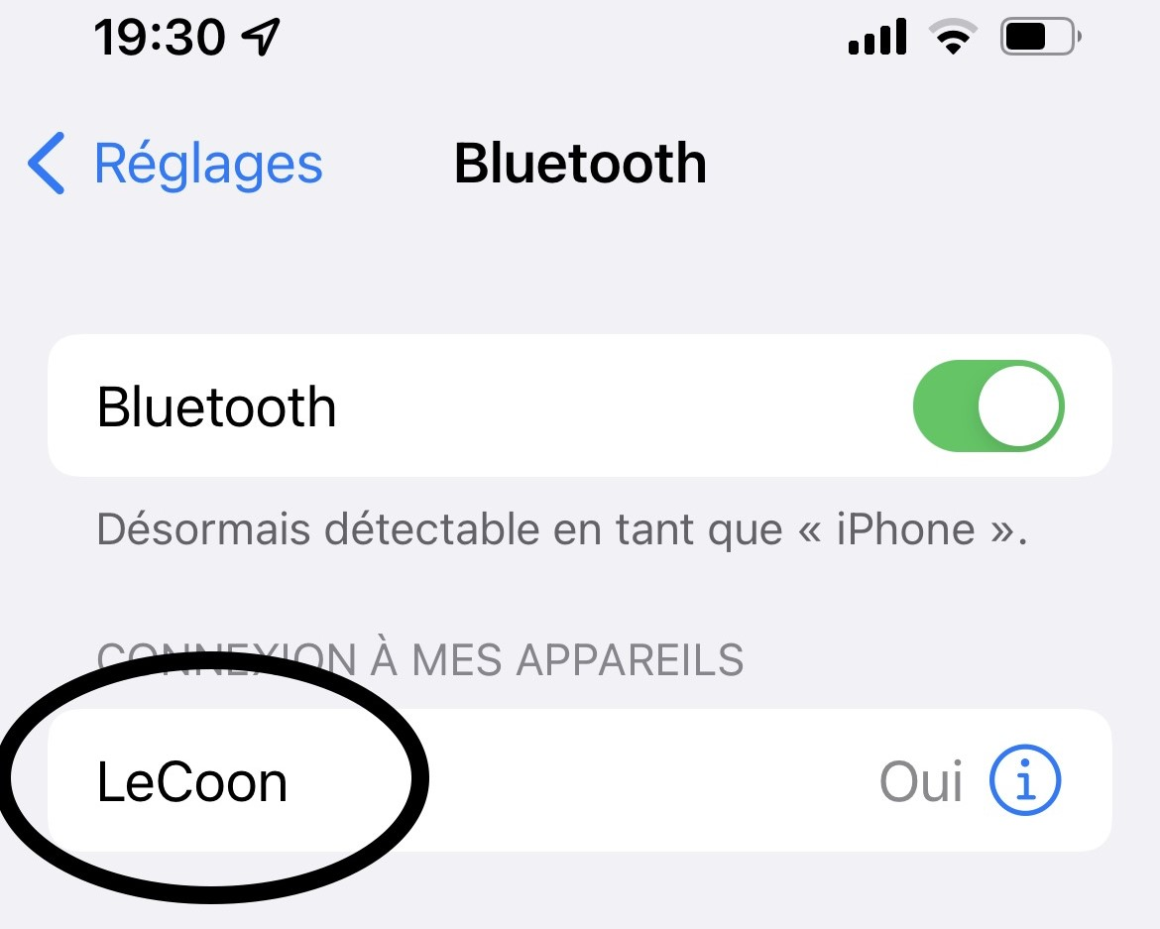  №3
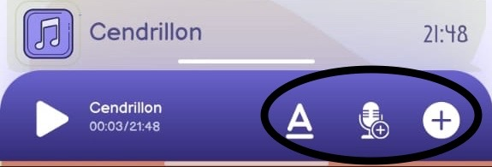  №4 | 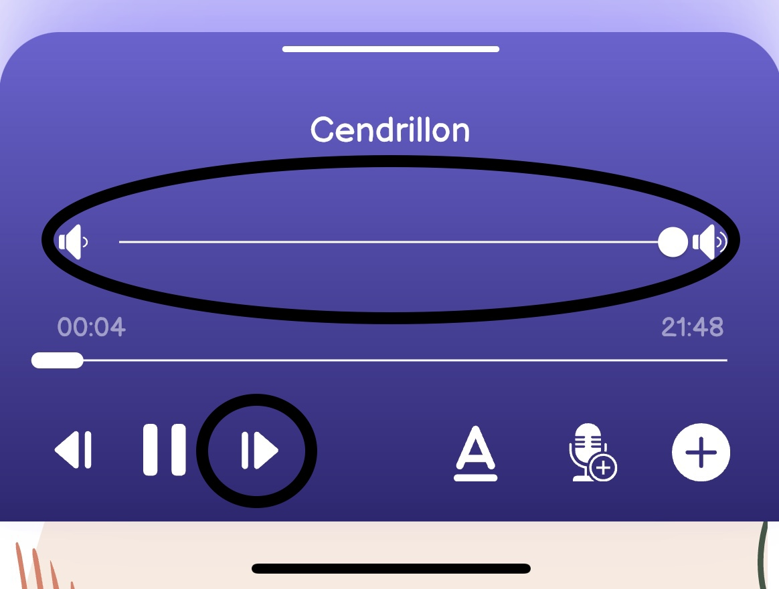  №5

